Chapter 3 – Applications of Differentiation

3.1 Introduction to Extrema

The following graph depicts the profit for a company from through August. If this was your company, what would be of notable interst?
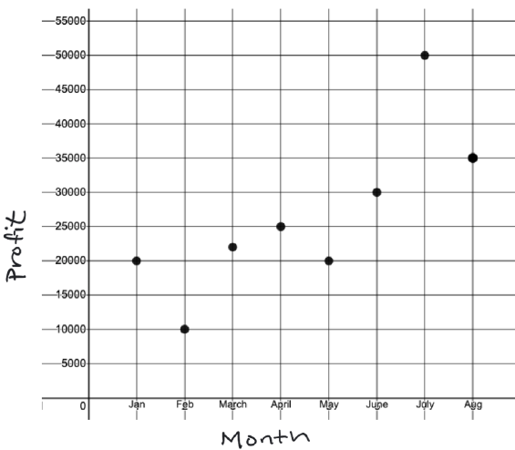

Absolute Extrema vs Local Extrema

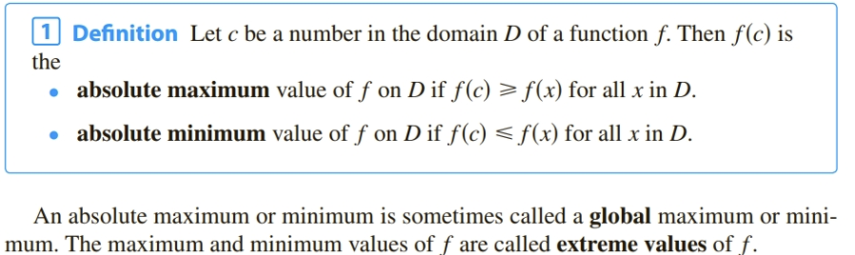
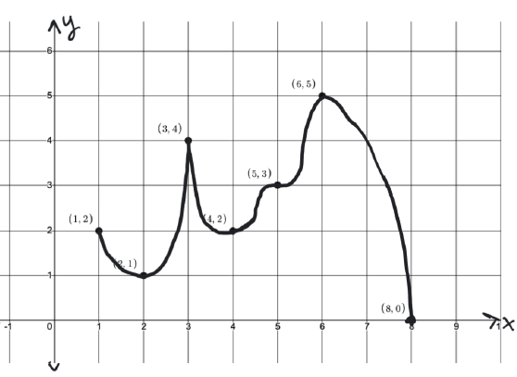
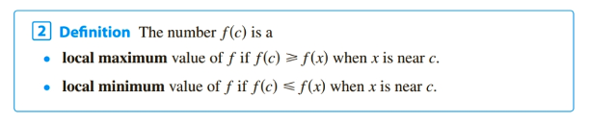
Clarification: “ x is near a” :__________________________________________________________ so local extrema cannot occur at __________

If there is an absolute extremum at c then there is also an local extremum at x=c unless ____________________________________
A little tricker: Identify extrema for each graph
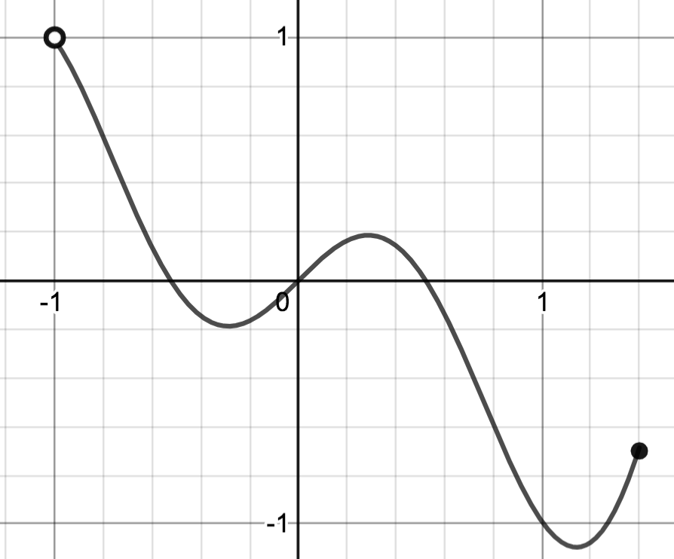
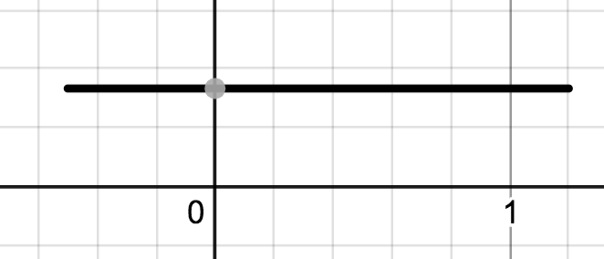
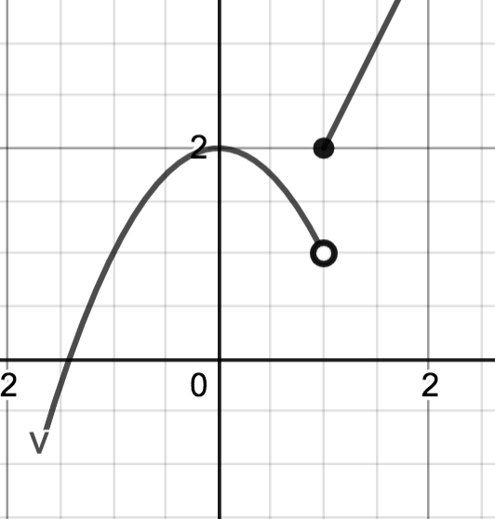

Vocabulary Details and Observations:

The absolute max is _____________. It occurs when x= _____________ at the point __________

The absolute min is _____________. It occurs when x= _____________ at the point __________

There are local minimums at the points:_______________________________

There are local maximums at the points: ______________________________

There are horizontal tangents at x=_____________________________

f(x) fails to be differentiable at x= _______________________________

If there is a local extremum for f at x=c then $f^{'}(c)$____________________________________ (These are called critical numbers)

If =0 or f is not differentiable at c (i.e. if c is a critical number) then f(x) __________________
have a local extrema at x=c. (see x=5)

Critical Numbers: A critical number of a function is a number c in the domain of f such that =0 or does not exist:

Find the critical numbers:

Recall, critical numbers give us a list of possibilities ___________________________________.

So finding critical numbers is __________________________________step to finding extrema.

What’s next? How do we know if these critical numbers actually yield extrema?

Start with a special case, then in 3.3 and 3.7 we will broaden our search.

Special case: f(x) continuous on a closed interval [a,b]

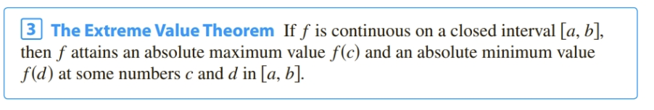

What did we observe earlier about where absolute extrema can occur?

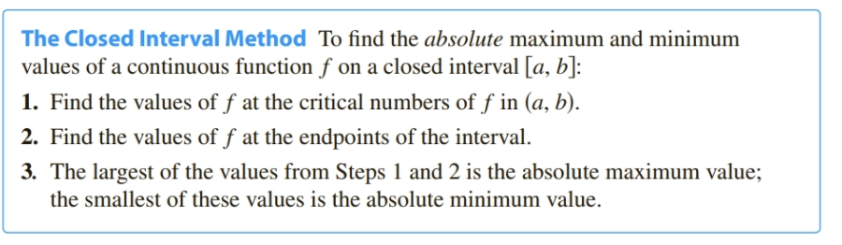

Example: Find the absolute extrema of on [-1,4]

What would happen if the interval was changed to (-1,4] ?
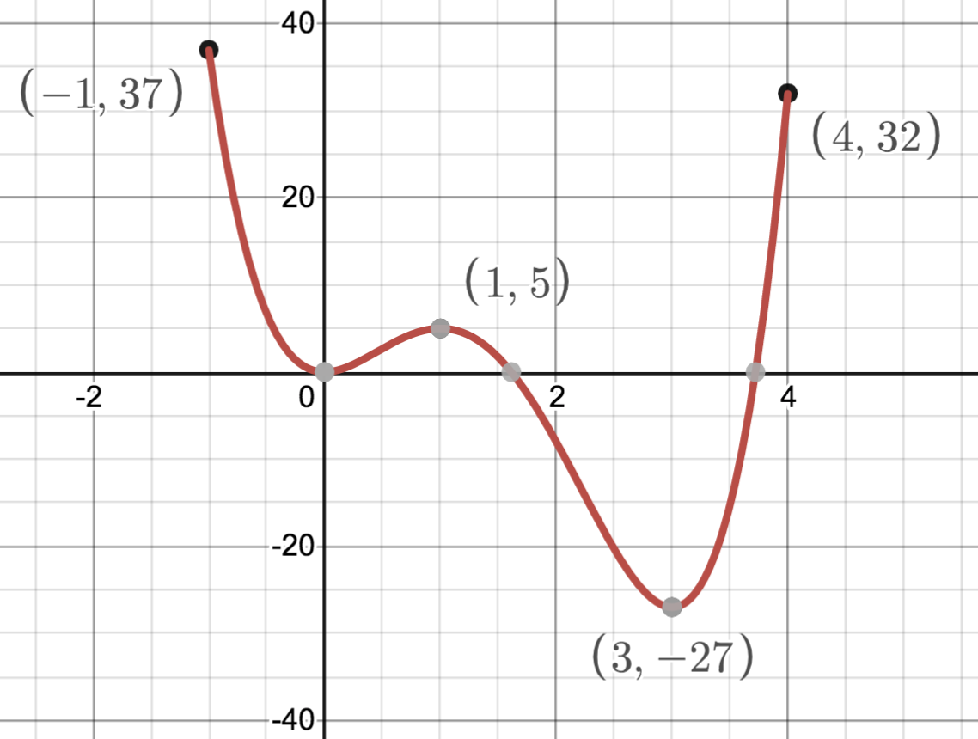
What about local extrema?

Applied problems: 3.7i

Example: What are the dimensions of the rectangle of largest area that can be inscribed in a semicircle of radius 4?
(see 5A page for Desmos animation: https://www.desmos.com/calculator/lfiles3gvj )

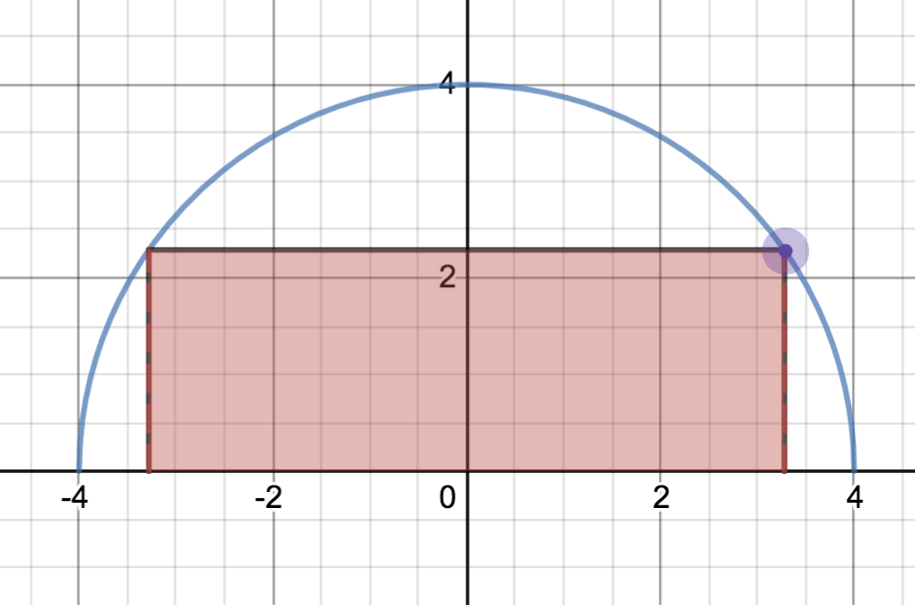

From last time…

Local extrema

Local extrema can only occur at __________________________________

Critical numbers occur for x values in the domain of f(x) such that ________________________ or ________________________

Critical numbers give a list of _____________________________x values for where local extrema __________________________ occur.

It is possible to have a critical number that ______________________________ lead to an extremum. (For example, f(x)=x³ at x=0)

A function may or may not have any local extrema.

Local extrema cannot occur at ___________________________ of the domain.

So out first step is to find critical numbers. Then what?.....3.3

Absolute extrema

If a function has absolute extrema, they occur at a _________________________ or at an _____________________ of the domain.

A function may not have any absolute extrema.

So out first step is to find critical numbers. Then what?.....3.7ii

In the special case where f(x) is continuous on a closed interval [a,b],the Extreme Value Theorem tells us __________________

So in this special case, we need only find critical numbers and _________________________________________________________________
( See: 3.1 Closed Interval Method )

3.3 Local Extrema and What Derivatives Tell us about a Graph.

Local Extrema – What does tell us about ?
Last time we looked at the absolute extrema of on [-1,4]

We found . When x=0,1,3, , so x=0,1,3 are our critical numbers. This means our function _________________ have local extrema at these values. If there ARE any local extrema, they can only happen at these values. But how do we know if these critical numbers yield local extrema. Consider what the sign of tells us.

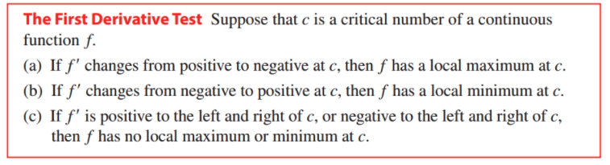

Example: Find local extrema for . Where is f increasing? Decreasing? Use this information to sketch a graph.

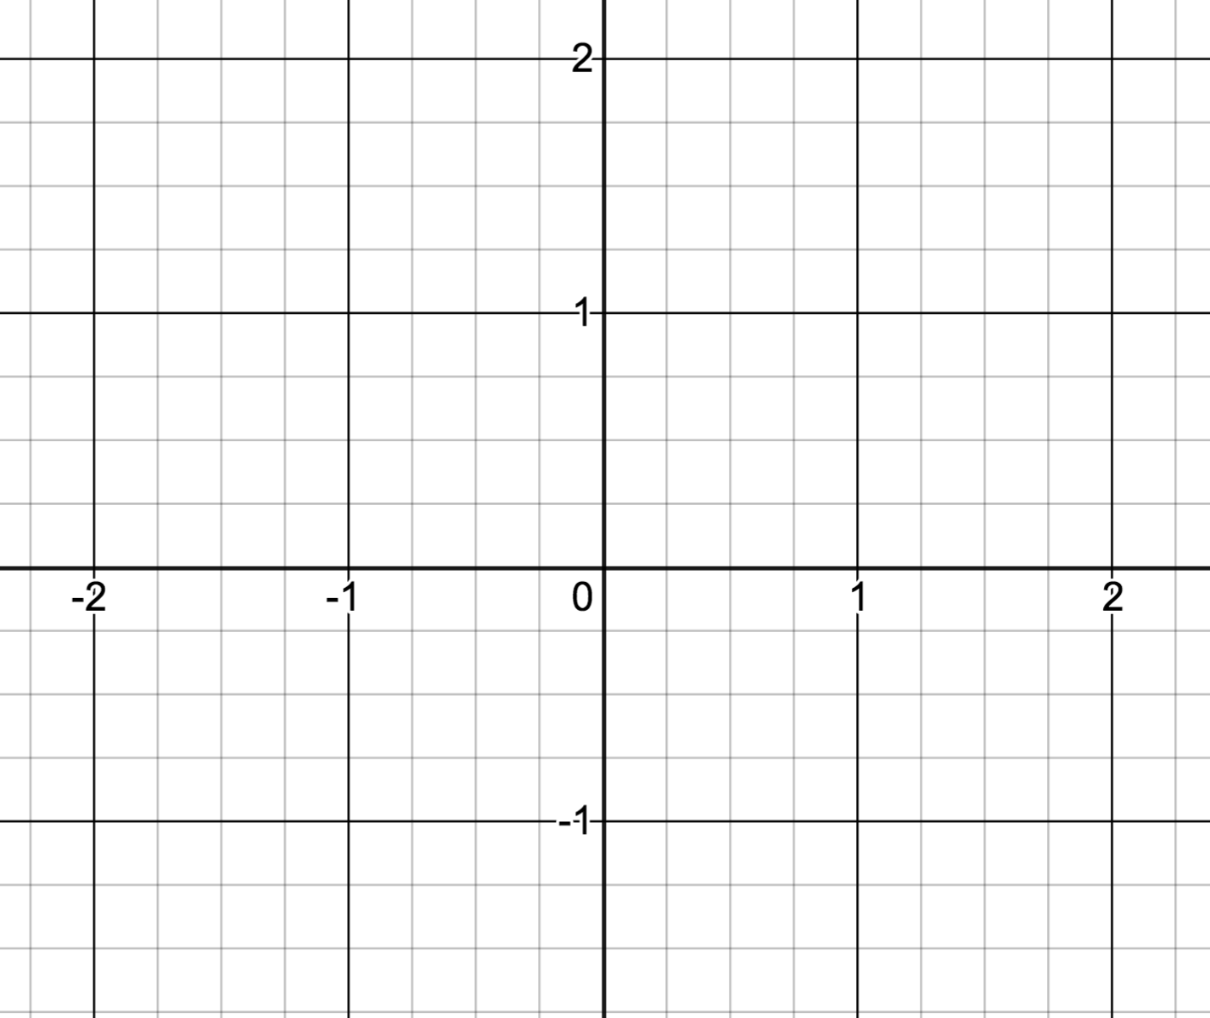

Example: Find local extrema for .

Concavity

Consider two functions, both increasing on the given interval. Remember that if a function is increasing,

then_________________________________________

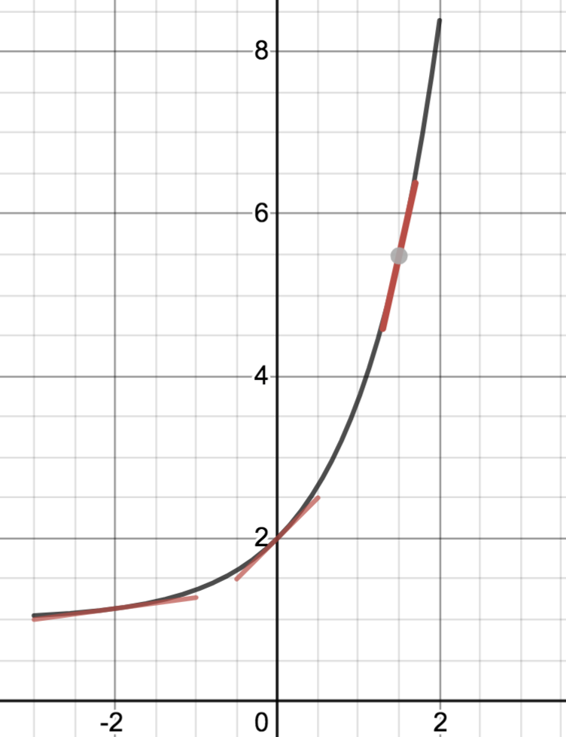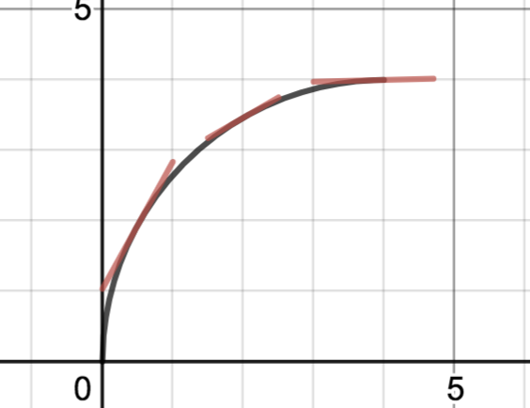

Concave UP Concave DOWN
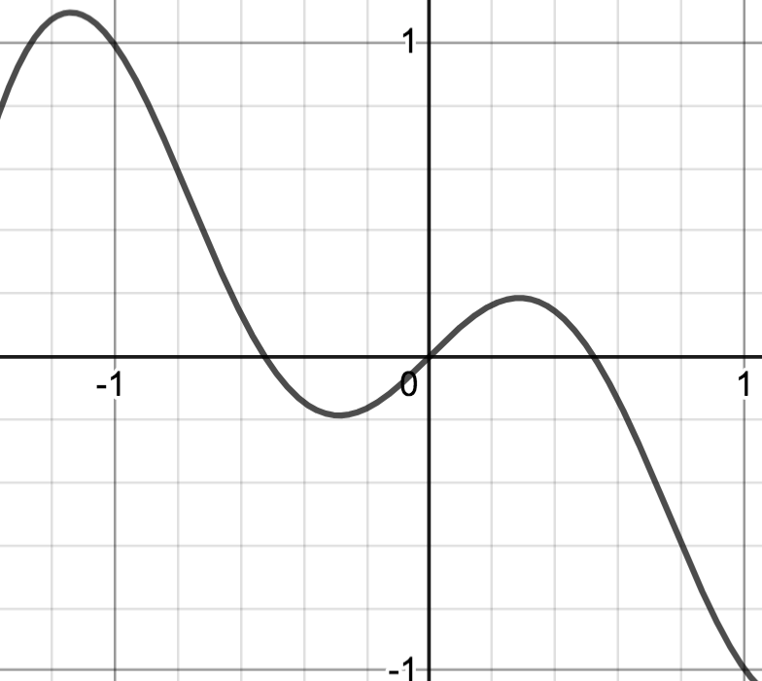
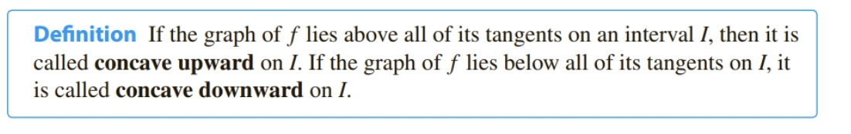
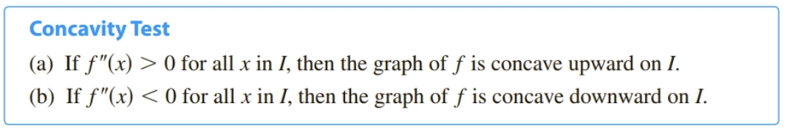
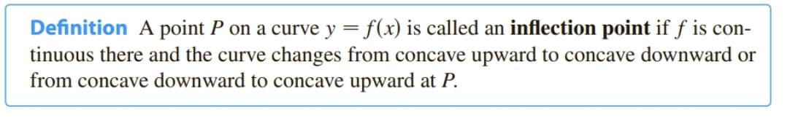

More on local extrema: Second Derivative Test
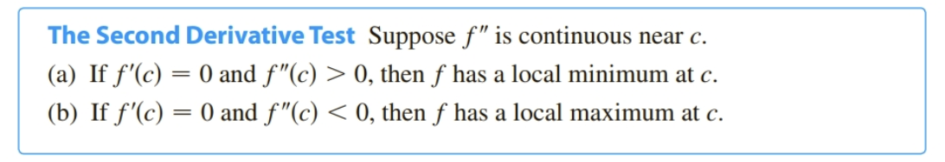

Revisit the earlier example and discuss concavity and inflection points.

Example: Given find and use them to graph the function.
$\begin{aligned} \\ f(x)=5x^{2/3}−2x^{5/3}=\text{____________________} \\ \\ f^{'}(x)=\text{____________________________________} \\ \\ f^{''}(x)=\text{_____________________________________}\end{aligned}$
What can we learn about the graph from ?
Domain

Behavior near domain issues/Discontinuities/Vertical Asymptotes

X intercepts

Y intercepts

Symmetry

End behavior

What can we learn about the graph from ?

Horizontal Tangents/Vertical Tangents/Cusps

Increasing

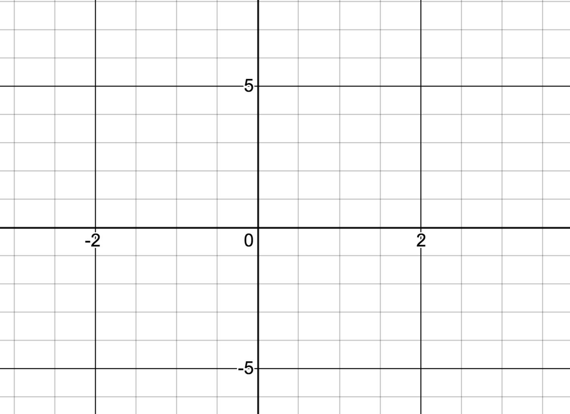
Decreasing

Local Extrema

What can we learn about the graph from ?

Concave UP

Concave DOWN

Inflection Point

Sketch the graph of a function that satisfies the following conditions
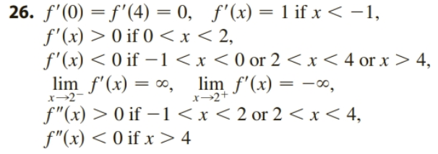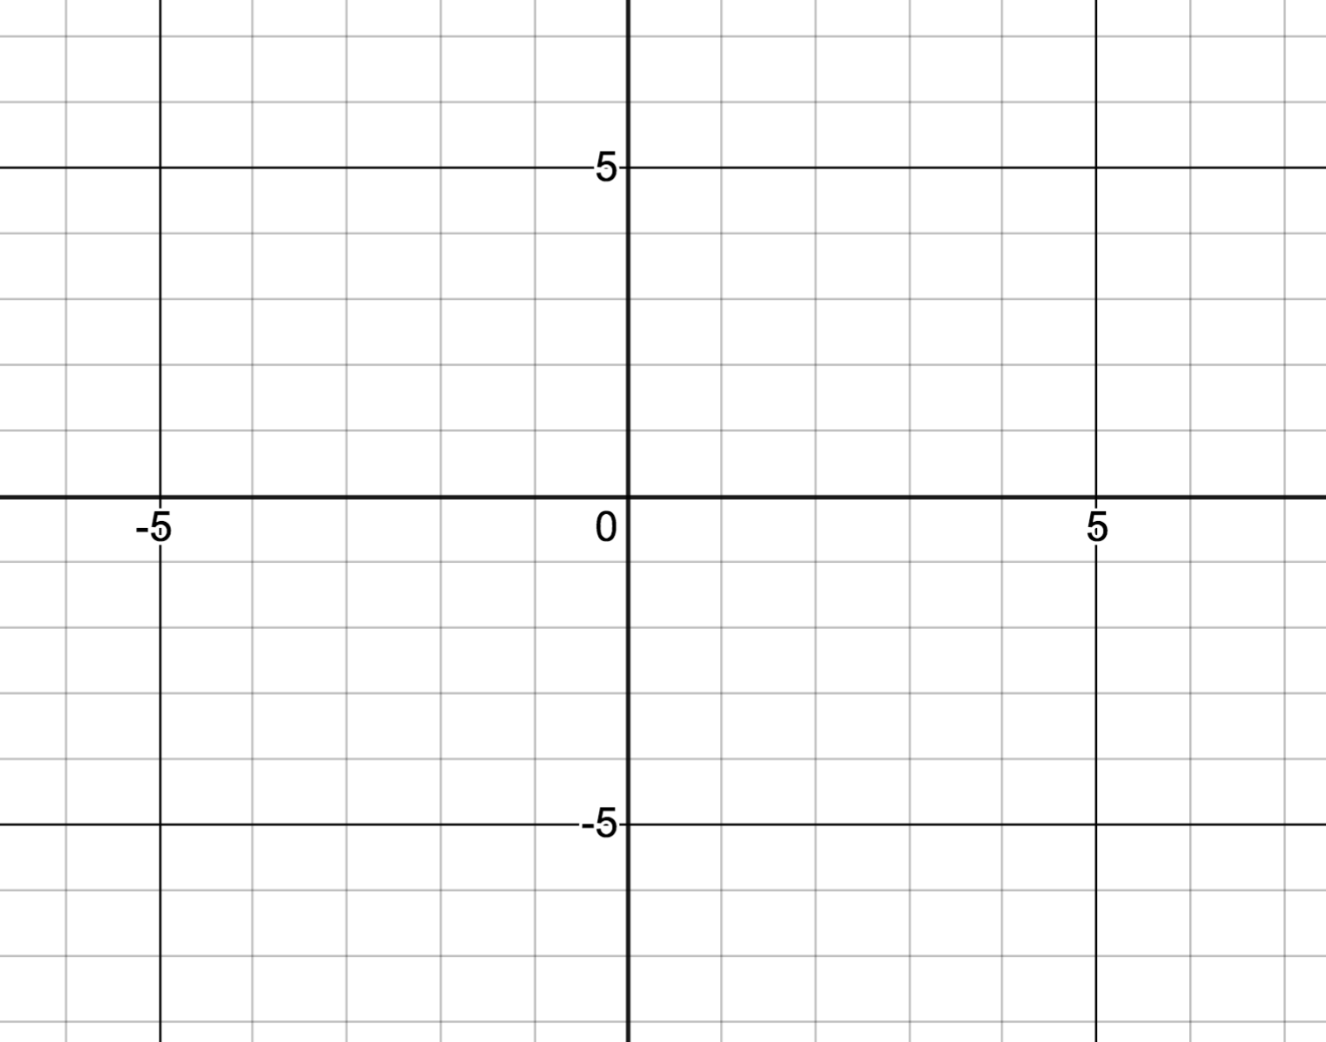

Example: Graph and discuss

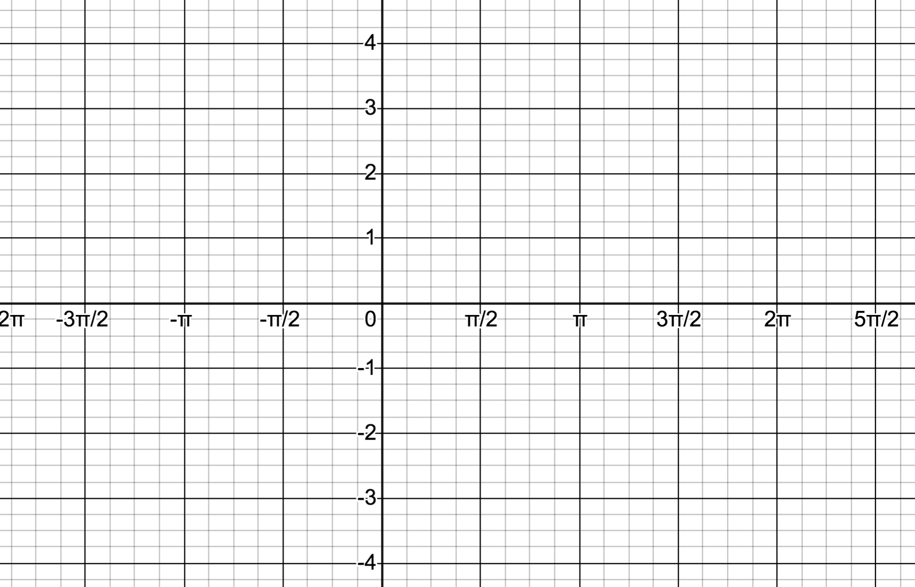

Example: Graph and discuss

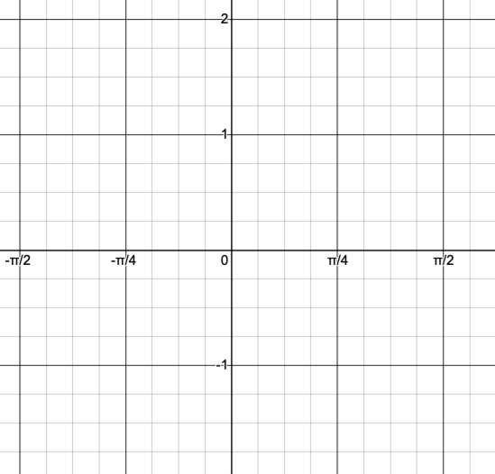

3.5 More Graphing – Asymptotes.

Vertical Asymptote: $\underset{x→}{\text{lim}}f(x)=$
“ “

End Behavior / Horizontal Asymptote:

Slant Asymptotes: , but in a predictable way.

Example: (using intuition since exponentials in 5B)

Note: There are also parabolic asymptotes, etc.

Example: Sketch and discuss

What can we learn about the graph from ?
Domain

Behavior near domain issues/Discontinuities/Vertical Asymptotes

X intercepts

Y intercepts

End behavior

What can we learn about the graph from ? $f^{'}(x)=\frac{x^{2}−2x}{(x−1)^{2}}$

Horizontal Tangents/Vertical Tangents/Cusps

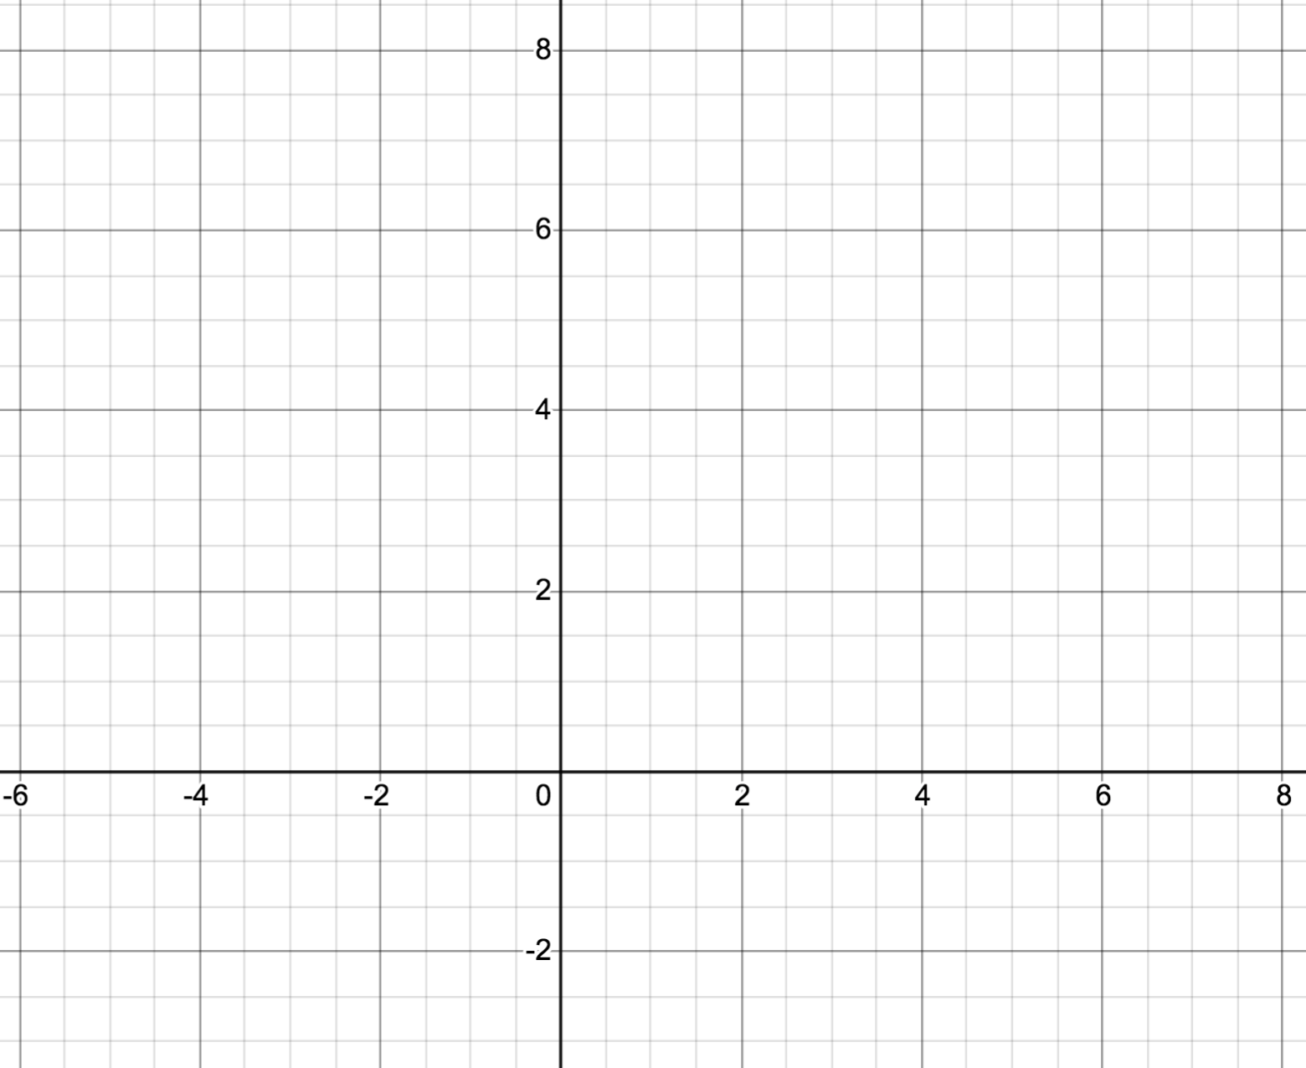
Increasing

Decreasing

Local Extrema

What can we learn about the graph from ? $f^{''}(x)=\frac{2}{(x−1)^{3}}$

Concave UP

Concave DOWN

Inflection Point

Example: Sketch and discuss

What can we learn about the graph from ?
Domain

Behavior near domain issues/Discontinuities/Vertical Asymptotes

X intercepts

Y intercepts

End behavior

What can we learn about the graph from ?

Horizontal Tangents/Vertical Tangents/Cusps

Increasing

Decreasing

Local Extrema

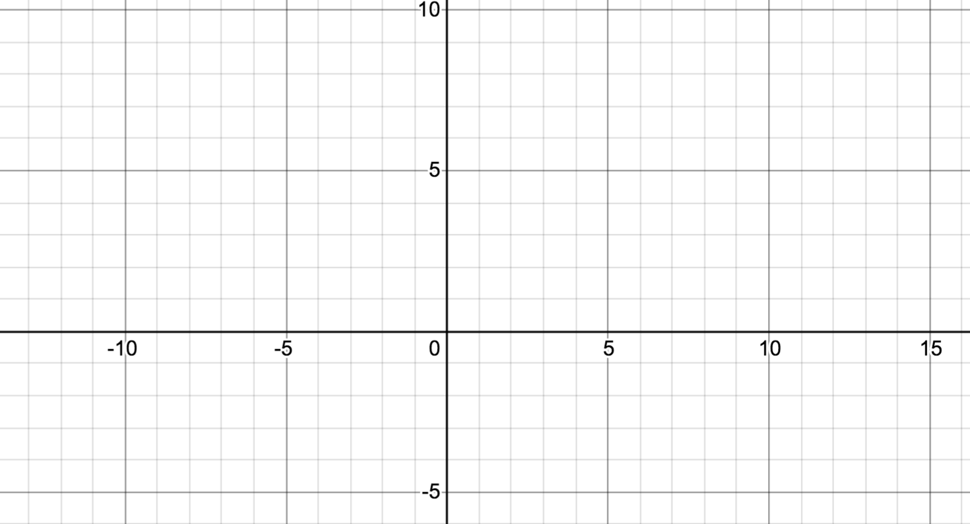
What can we learn about the graph from ? $f^{''}(x)=\frac{5(4x−5)}{4x^{3/2}(x−5)^{5/2}}$

Concave UP

Concave DOWN

Inflection Point

3.7ii Absolute Extrema

Previously we discussed finding absolute extrema in the special case where f(x) is ________________________ on __________________

What makes that case special is ___________________________________________________________________

How do we find absolute extrema if we don’t have this special case?

Example: Find the absolute extrema of on [-1,4]

Method? We have to _________________________

We start by finding critical numbers, but how do we VALIDATE that those crit. #s actually lead to absolute extremum?

In physical problems, we can often validate existence of an absolute extremum with a physical explanation.

Example:
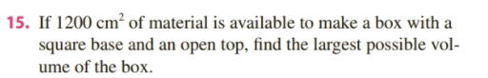

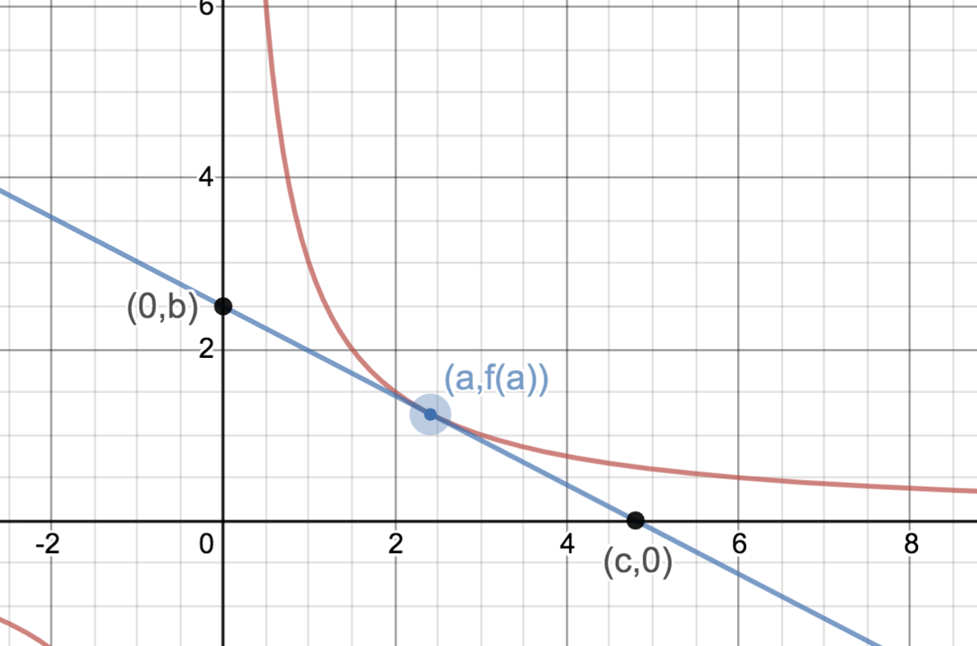
Example: See desmos animation on 5A page: https://www.desmos.com/calculator/0ckuig0ohk
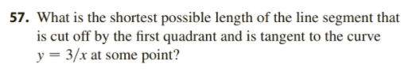

3.2 Rolles Theorem and the Mean Value Theorem

We are going to look at two very important theorems that give an algebraic relationship between

Intuitively: Suppose you were asked to sketch a graph of a function defined on [a,b] with the only requirement be that is continuous and differentiable.

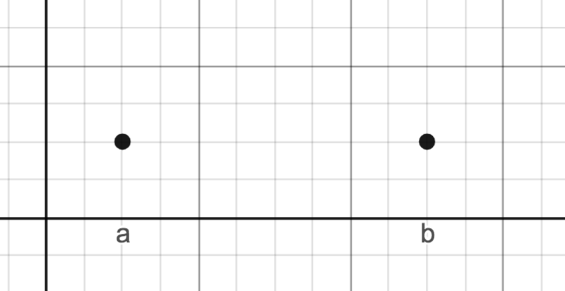

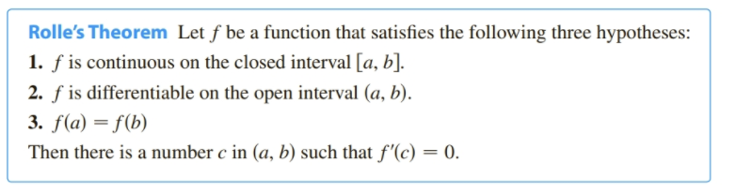

Why continuous necessary? Why differentiable needed?

Proof of Rolle’s Theorem (different than book)

The Extreme Value Theorem tells us that if a function is continuous on closed interval [a, b}, then

Case 1: Supposed m=M

Case 2: Suppose $m¹M$

Example: For the following two functions: Does Rolle’s Theorem apply on the given interval? If so, find “c”

Rolle’s Theorem is often very useful in proofs.

Example 2 pg 221: “Existence and Uniqueness Proof”
Prove that the equation has exactly one real root.

To prove exactly one we must prove two things: at least one (Existence) and not more than one (Uniqueness)

At least one:

Not more than one: “Proof by Contradiction”

Mean Value Theorem MVT
Intuitive Idea:
(1) Suppose you average 40 mph on your way home. Are you ever going exactly 40 mph?

(2) Suppose you were asked to sketch a graph of a function defined [a,b] with the only requirement be that is continuous and differentiable.

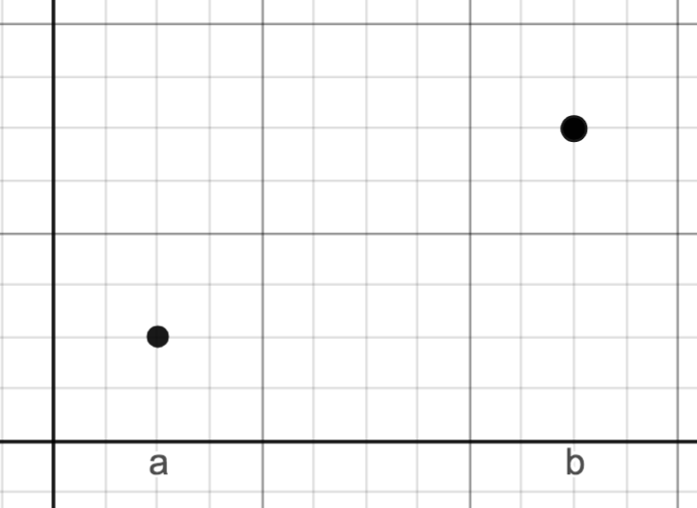

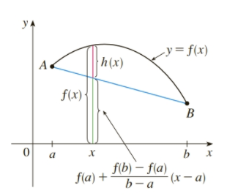
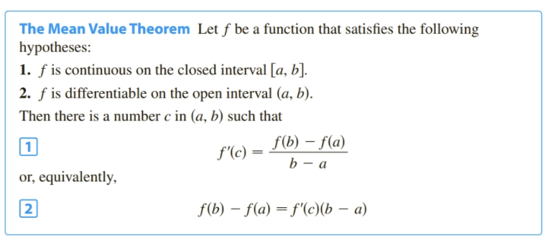
Proof of MVT:
Let be the vertical distance between and the line connecting A and B as shown:

Apply Rolle’s Theorem to on [a,b]

Example: Does The Mean Value Theorem apply to interval [1, 2]? If so, find “c”

The MVT is often used in proofs:

Prove that if on an interval then is increasing on that interval.

We’ve been using this as fact, but it has not been proven.

See book’s proofs of Theorem 5 and Corallary 7 on page 224+.

